**HW04**

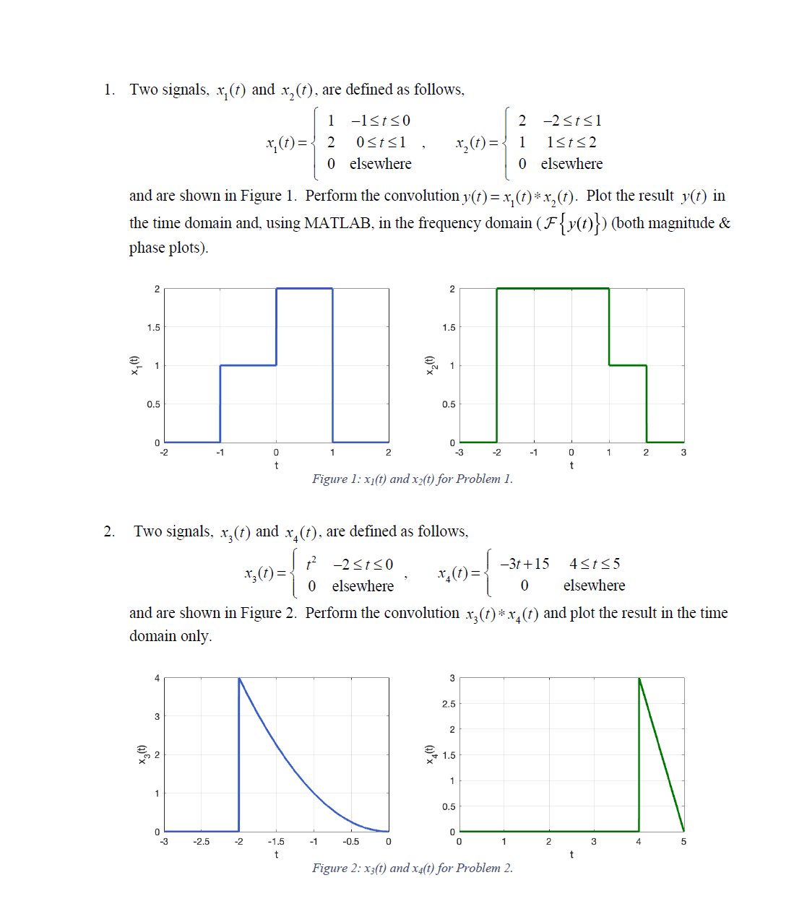

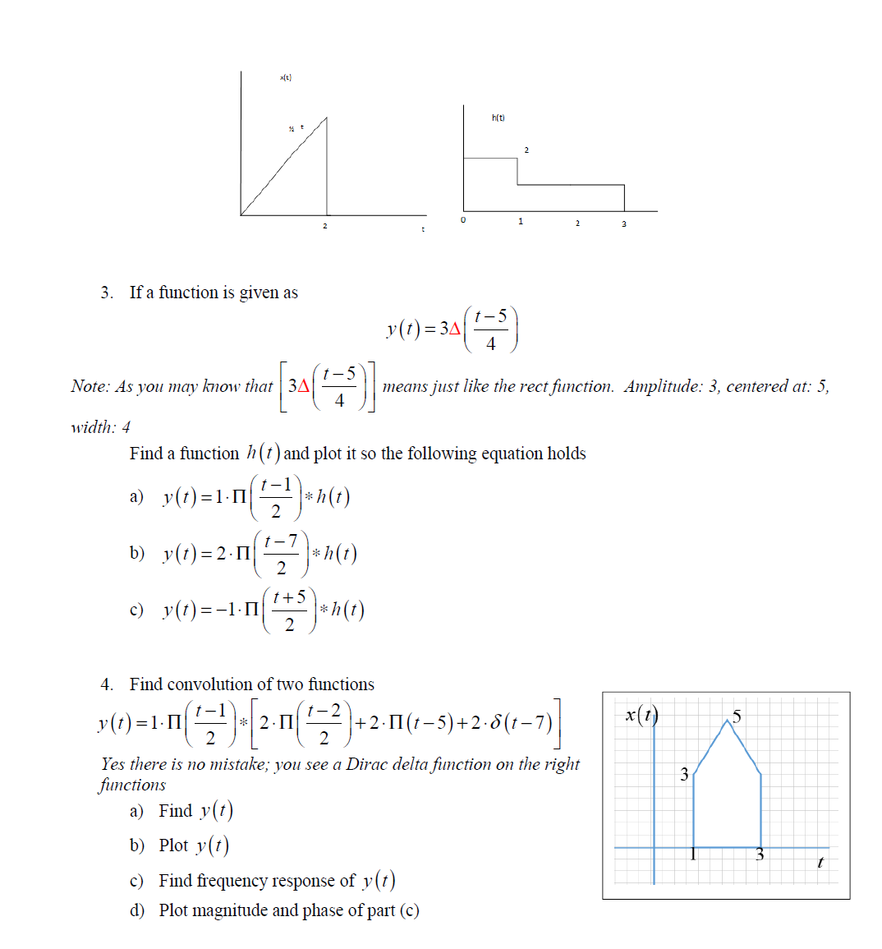

1. In class, we proved that convolution in the time domain corresponds to multiplication in the frequency domain. That is,



where  denotes the Fourier transform of . **Now show** that convolution in the frequency domain corresponds to multiplication in the time domain:



where  denotes the inverse Fourier transform of .

1. Convolution
   1.  is shown in Figure 1. Perform the convolution; that is,  convolved with itself. And plot  in magnitude and phase where 

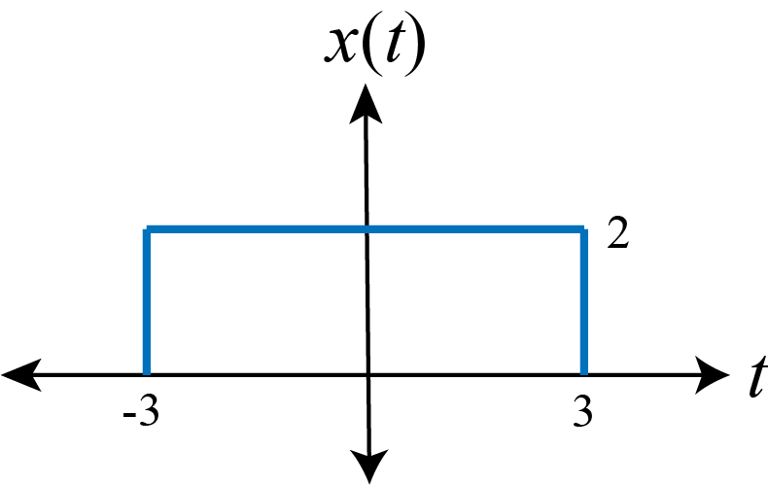

Figure 1: x(t) for problem 2(a).

* 1.  and  are shown in Figure 2. Perform the convolution. And plot  in magnitude and phase where 

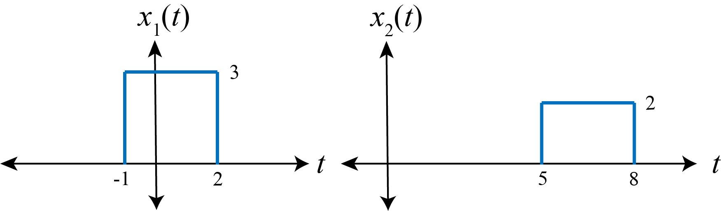

Figure 2: x1(t) and x2(t) for problem 2(b).

1. Output of a filter, , is shown below.

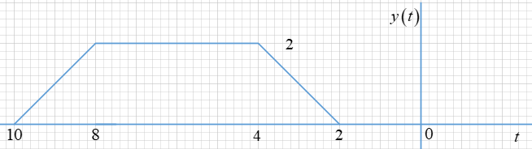

If input, , is given as shown below,



1. Find  and plot it.

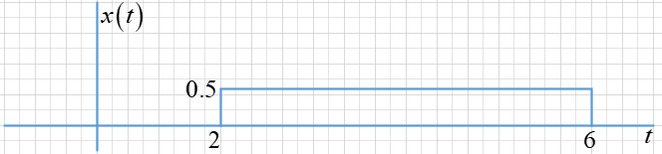

1. Find based on 
2. Plot magnitude and phase of using tools. 

If filter, , is given as shown below,

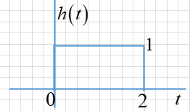



1. Find  and plot it.
2. Find based on 
3. Plot magnitude and phase of  using tools